1. Say Hi

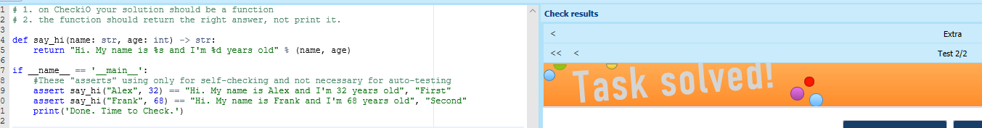

1. First Word

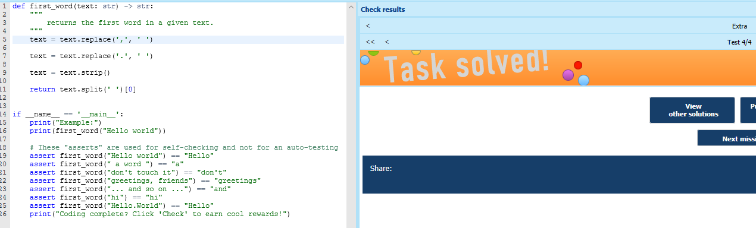

1. Popular Words

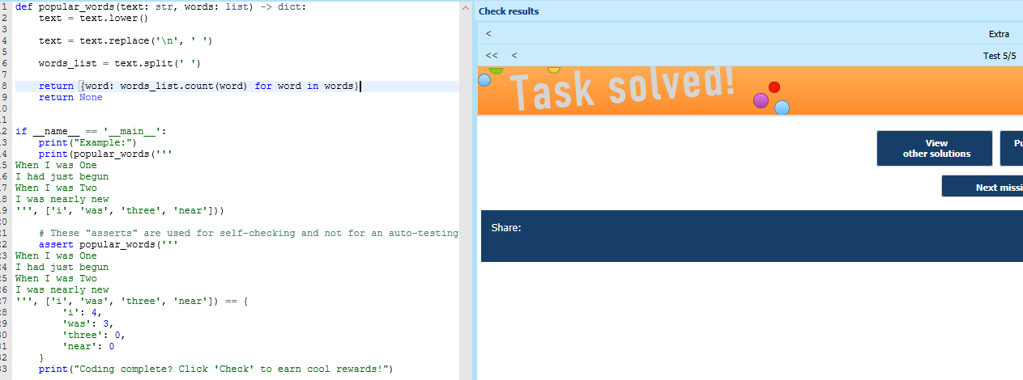

1. Bigger Price

